Potawatomi Women Leaders
Educational Materials for Broadcast # 5 – March 2021
“Indigenous Perspectives” program
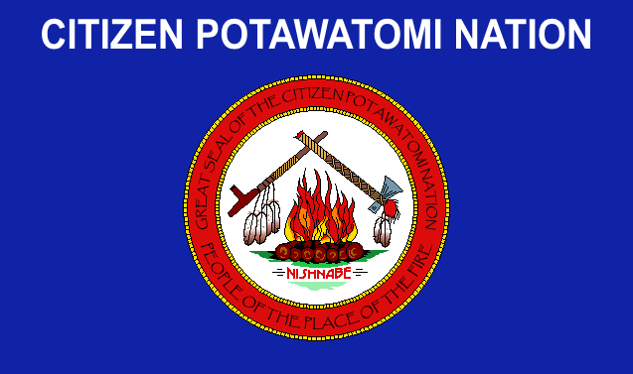
Flag of the Citizen Potawatomi Nation
Wikipedia Commons - Creative Commons license CC BY-SA 3.0

- Flag of the Citizen Potawatomi Nation
A flag has emotional and symbolic meaning to the people it represents. The flag of the Citizen Potawatomi Nation contains symbols of items important to the CPN people. These include: tomahawk “NISHNABE”
fire calumet (“peace pipe”) seven logs eagle feathers

Find each of these six items on the flag, and then match each of them to the best explanation of their meaning below:
1. the seven independent Potawatomi tribes in the US ____________________
2. the shared lives and responsibilities of the Ojibwe,
Odawa and Potawatomi (Council of the Three Fires) ______________________

3. acknowledges these birds as spirit messengers, and
warriors who defend their people ______________________

4. shows strength and willingness to protect the Potawatomi
from dangers ______________________

5. shows diplomatic skill and willingness to seek friendship
and cooperation with others _____________________

6. the Potawatomi word for “person” _____________________

II. Vocabulary used in the show - Match the words and their definitions below (note that there is one extra word).
Aninishinaabe constitution dual citizenship
geneology legislature Moontime Potawatomi
resiliency reservation sovereignty treaty

- a formal legal agreement between two independent governments
- ability to survive and “bounce back” in the face of hardships and suffering
- an area set aside for a certain group of people to live in
- a woman’s menstruation time, each month
- having legal and political rights as a member of two different nations at the
same time

- the science of tracing families through generations

- a part of a government that creates laws that guide people’s behavior;
members often represent different geographic areas

- name for the large group of indigenous peoples with a shared culture and
language base that includes the Ojibwe, Odawa and Potawatomi

- a plan of government that explains the rights and responsibilities of people in different parts of the system, so that everyone understands what is involved

- the right to rule oneself; the supreme power over a territory

- Map of the Native Peoples of the Northwest Territory, 1792
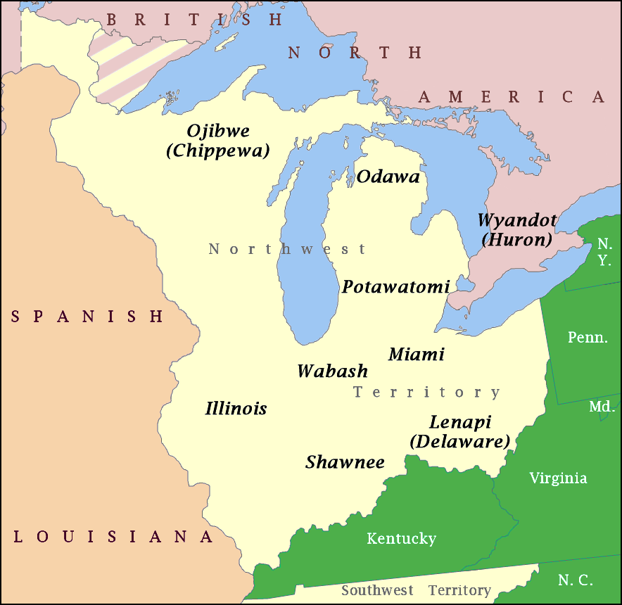
Northwestern Confederacy 1783-1795
https://en.wikipedia.org/wiki/Northwestern_Confederacy#/media/File:NW_Native_Tribes,_1792.png

Questions about this map

- On the map above, the green color means
- Land lived on and controlled by Native Americans in 1792
- Bodies of water (Great Lakes)
- Land claimed by the Kingdom of Spain
- Land controlled by the British, after their defeat of the French
- Land that is part of the United States in 1792

- The blue color means:
- Land lived on and controlled by Native Americans in 1792
- Bodies of water (Great Lakes)
- Land claimed by the Kingdom of Spain
- Land controlled by the British, after their defeat of the French
- Land that is part of the United States in 1792

- The lightest color (sort of off-white) means:
- Land lived on and controlled by Native Americans in 1792
- Bodies of water (Great Lakes)
- Land claimed by the Kingdom of Spain
- Land controlled by the British, after their defeat of the French
- Land that is part of the United States in 1792

- The beige (light brown) color means:
- Land lived on and controlled by Native Americans in 1792
- Bodies of water (Great Lakes)
- Land claimed by the Kingdom of Spain
- Land controlled by the British, after their defeat of the French
- Land that is part of the United States in 1792

- The lavender (light purple) color means:
- Land lived on and controlled by Native Americans in 1792
- Bodies of water (Great Lakes)
- Land claimed by the Kingdom of Spain
- Land controlled by the British, after their defeat of the French
- Land that is part of the United States in 1792

IV. Map of Potawatomi Removals, 1830s
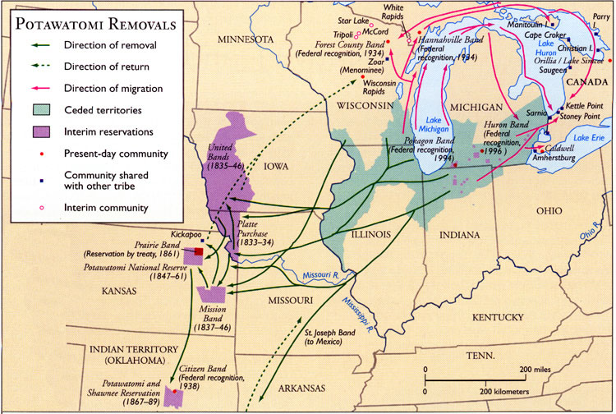
Map credit: Kalamazoo Public Library website
https://www.kpl.gov/local-history/kalamazoo-history/native-americans/match-e-be-nash-she-wish/

- What color is used on this map to show the original lands of the Potawatomi, which they gave up to the US by treaty, in exchange for promises of land and resources elsewhere?

- What color is used on this map to show places that Potawatomi were allocated to move to, temporarily, and then moved out of?

- The green arrows show paths of removal – routes that people being dislocated by US government orders were forced to travel along, away from their homelands. How does the map show that some people from different groups escaped and returned closer to their original homelands?

- Some groups of Potawatomi moved to safer areas and re-settled on their own, avoiding the forced removals and assigned reservation areas. How does the map show their movements?

- Which statement best summarizes the geographic pattern of removal of the Potawatomi people?
- Away from prairie and desert, into forested areas
- Away from the seacoast, into the dryer interior of the continent
- Away from the interior, toward the seacoast
- Away from lakes and woodlands, into prairie and plains

- The 7 Different Potawatomi Bands

During the19th century times of their forced removal, relocation, re-settlement, and migrations, the Potawatomi people divided up into different tribal groups, or Bands. They gradually developed different Band identities as they settled in particular areas. Today, seven Potawatomi bands in the United States have achieved Federal recognition as Indian Nations. Each Band makes its own rules about membership, selects its own form of government, and has its own website. They are:
Citizen Potawatomi Nation (formerly Citizen Band Potawatomi)
Forest County Band
Hannahsville Band
Huron Band
Gun Lake Tribe (located in Michigan; not shown on the map; Fed recog. 1999)
Pokegon Band
Prairie Band
The “Map of Potawatomi Removals, 1830s” also shows the location of 6 of the present-day band tribal headquarters, and the date of their recognition by the US government.
Refer to the “Potawatomi Removals” map on page 5 above, to think about these questions on the Seven Different Potawatomi Bands:
- Which two bands managed to stay on land within the ceded territories of the traditional Potawatomi area of the Great Lakes region?
- In what present-day US state are those two bands located?
- Many members of one band shown on the map ended up moving (on their own) to Mexico, where they maintain their community today. What is their band’s name?
- Only one Potawatomi band is based in present-day Oklahoma – which one is it?
- Which band has its community in present-day Kansas?
- Two bands are located in present-day Wisconsin, and have their historical roots in migration from other areas. Which two bands are these?

- Potawatomi Trail of Death
In 1838, as part of the process of “Indian Removal”, Potawatomi living in communities in northern Indiana – often side-by-side with white settler families – were forced by US Federal and local military to leave their homes behind, and to travel at gunpoint overland to an area in Kansas. This two-month ordeal became known as the Potawatomi Trail of Death.
Along the Missouri River in Wellington, Missouri
is the route of the Potawatomi Trail of Death.
Photo credit: Chris Light https://en.wikipedia.org/wiki/Potawatomi_Trail_of_Death
Creative Commons Attribution-Share Alike 4.0 International
In 1988 (the 150th anniversary of the Trail of Death), elders from the Citizen Potawatomi Nation decided it was time to re-connect with their history and to heal wounds. They organized the Trail of Death Commemorative Caravan and re-traced the route, stopping for discussions and reunions in the towns along the way.
As public awareness of this history has grown, commemorative markers have been placed along the Trail of Death, to show respect and remembrance of this tragic event. The caption on the marker above reads: “On Saturday October 27th, the Potawatomi Indians camped in Wellington at the Little Schuy Creek (Big Sni). On Sunday October 28, a Potawatomi child died. Erected by Boy Scout troop #317 On behalf of the Wellington Community, Aug. 26, 2000.”
The Trail of Death is significant for many Potawatomi today, as it marked a major turning point in their existence as a nation. Of the 859 people who were driven out of their homes in Indiana, 42 died along the way, 61 escaped the soldiers and found their way back north to join with other Indian communities, and 756 arrived at the Kansas destination.
While the survivors settled in to their new Kansas reservation, after some years they were threatened with removal again. Those who stayed on Kansas, in a reservation area, became the Prairie Band. Those who took an offer from the US government in 1861, to take US citizenship and move to Oklahoma to have individual allotments of land, became the Citizen Band. This decision toward more assimilation with mainstream American culture, while keeping their Potawatomi identity, kinship, cultural and spiritual roots, set some of the foundation for the Citizen Potawatomi Nation.
Suggestions for Research and Discussion
- Find out more about the Potawatomi Trail of Death and its commemoration in recent decades. What can people today – both Indian and non-Indian – learn from these events?

- Choose another group that had to cope with forced dispossession and re-settlement. Compare their experiences with those of the Potawatomi, focusing on ways that the survivors and their descendants have shown resilience. [Many Native American peoples have had these experiences, such as the Cherokee Trail of Tears (1838-1839) and the Long Walk of the Navajo (1864). You may also choose a non-Indian group, such as Africans dispossessed and forcibly transported to the Americas from the 1400s through the mid-1800s, Ukrainians in the Soviet Union in the 1930s, or Japanese-Americans during World War II. ]

- The Work of Eva Marie Carney and Paige Willet for the CPN
Note: you may want to listen to the audio show again, or read over the transcript, before answering these questions about the guests’ work for the CPN.
Link to audio podcast: http://www.ecologia.org/news/5.PotawatomiWomenMar2021.mp3

- Eva Marie Carney says that “…first being in Kansas and then, you know, the removal or agreement to move, I guess, to sell land and move to Oklahoma really was a choice that really was, you know, a choice that was not really a choice.”
What does Eva Marie mean by “a choice that was not really a choice”?
- The Potawatomi were forced at gunpoint to move to Oklahoma
- The individual families couldn’t choose; their leaders made the choice
- There was no land available for the Potawatomi in Kansas
- It seemed like the best way out of constant insecurity about land rights on a reservation

- Paige Willet says, “We have been forcibly removed and dislocated for hundreds of years.” This is an explanation for why:
- The Citizen Potawatomi are different from other Potawatomi
- The Potawatomi want to forget about the Trail of Death
- Potawatomi today live in many different communities across the US
- Most Potawatomi today live in the Great Lakes region of their ancestors

- “The goal I think for so many of us is to connect with our past and move into our future….we owe it, I think, to those in whose path we’re now walking, to be our best selves and to carry on for the next seven generations.” Eva Marie Carney sees herself as “moving into our future” by her work as:
- an elected member of the CPN legislature
- a member of the Haudenosaunee people
- the curator of the CPN Cultural Heritage Center
- a Potawatomi representative in the Oklahoma State Legislature

- Paige Willet says, “There are CPN members who take great pride in their heritage and in their culture, who may not be directly on or near tribal land or work for the tribe, or are able to participate in every single thing that’s going on.” Which is the best conclusion to draw from this statement?
- Most of the CPN members lack knowledge about the tribe’s history.
- Very few CPN members live in Oklahoma.
- Since the CPN members are geographically scattered, they need to connect through avenues such as the newspaper and their legislators.
- Most of the CPN members struggle with racial discrimination from their non-Indian neighbors.

- Paige Willett says “You know, women are the water keepers and the water protectors in the Potawatomi tribe.” Eva Marie Carney points out that the theme of the Kwek Society is “celebrate Moontime”. In statements like these, both of these leaders are emphasizing:
- the damage done to tribal identity by experiences in the 19th century
- a positive view of women, rooted in traditional Potawatomi culture
- problems with the all-male Citizen Potawatomi Nation legislature
- the benefits of achieving US citizenship during the move to Oklahoma

- Map of CPN Legislative Districts, Present-Day
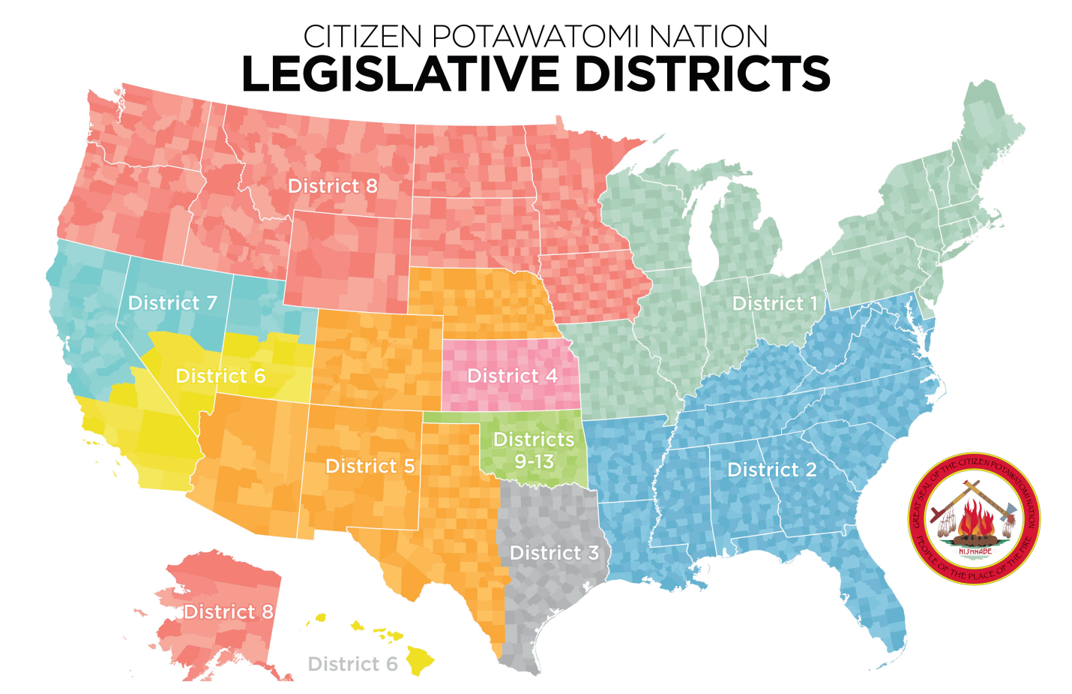
Map credit: Citizen Potawatomi Nation www.potawatomi.org
- Each District has one elected CPN legislator. Eva Marie Carney lives in
Virginia, and is the elected CPN Potawatomi Legislator from her district.
- Find her district on the map; what color is it?
- Each district has a number; what is Eva Marie’s district’s number?

- One state clearly has the most Citizen Potawatomi Nation members living in it.
A. What is that state’s color on the map?
- How many CPN legislators in total are from that one state?
- Name that state.

- Are there Potawatomi tribal members in Hawaii?

- Explain why some legislative districts cover much more land than others.

- How would you describe the information on this map, to a friend who has not seen it? (Put into words what you can learn from the map about the people of the Citizen Potawatomi Nation).
Answers
- Flag questions
- seven logs
- fire
- eagle feathers
- tomahawk
- calumet (peace pipe)
- NISHNABE (pronounced “nish-na-bay”) (emphasis on the last syllable)

- Vocabulary questions
- treaty
- resilience
- reservation
- Moontime
- dual citizenship
- geneology
- legislature
- Aninishinaabe
- constitution
- sovereignty

- Map of Native Peoples of Northwest Territory, 1792
- e
- b
- a
- c
- d

- Map of Potawatomi Removals, 1830s
- green (blue/green)
- purple
- green dotted arrows
- red arrows
- d
V. The Seven Different Potawatomi Bands
- Huron Band and Pokegon Band
- Michigan
- St. Joseph Band
- Citizen Band (Citizen Potawatomi Nation)
- Prairie Band
- Forest County Band and Hannahsville Band
VII. Connections with Carney and Willet
- d
- c
- a
- c
- b
VIII Map of CPN Legislative Districts
- A. blue B. District 2
- A. green B. Five legislators (Districts 9-13) C. Oklahoma
- Yes
- Each legislator needs to represent roughly the same number of CPN members. So in areas where CPN members are scattered rather thinly, it takes more land area to have the number of CPN members add up. Because Oklahoma has many more CPN members living there, it’s divided up into 5 separate districts. There are five times as many Citizen Potawatomi living in Oklahoma as in all of District 2!
- Answers will vary. Some examples: the map shows the population distribution of Citizen Potawatomi members throughout the United States; you can see that many live in the Midwest (Oklahoma, Kansas), but that there are CPN members widely distributed in all of the US states.

Attribution-NonCommercial-ShareAlike CC BY-NC-SA
Creative Commons License Others may remix, adapt, and build upon this work non-commercially, as long as they credit “Indigenous Perspectives – Randy Kritkausky & Carolyn Schmidt” and license their new creations under the identical terms (ie non-commercial; share with attribution.)
Materials reviewed and updated, March 2023 - CS

