A Canadian Mohawk First Nations Perspective – Tom Dearhouse
Educational Materials for Broadcast # 3 – January 2021
“Indigenous Perspectives” program

1. Photos taken at Kahnawake Reserve
From the photos below, what can you figure out about life on Kahnawake? If you took similar photos in your own community, how would they be similar, and how would they be different?

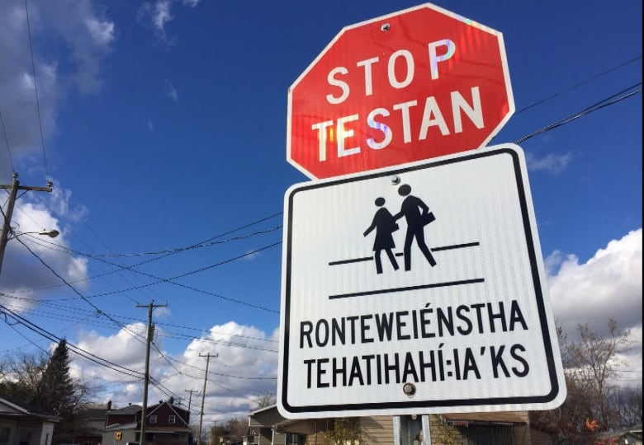
https://www.cbc.ca/news/canada/montreal/kahnawake-road-signs
-1.4380334 Simon Nakonechny/CBC
https://www.cybersoleil.com/the-challenge-of-being-a-policeman-on-mohawk-territory/
- Map of Haudenosaunee (Iroquois) Territory Past and Present

https://native-land.ca/maps/territories/haudenosauneega-confederacy/
This map does not have a “Key” – a list of the different colors and what they represent. So, the viewer has to figure them out, in order to understand the map and its message. [“Haudenosaunee” and “Iroquois” are two different names for the same group of people.]

- What does the blue color on this map mean?

- What does the red color on this map mean?

- What does the green color on this map mean?

- What does the yellow color on this map mean?

- What does the white color on this map mean?

- Name the five Haudenosaunee (Iroquois) nations shown on this map.

Map questions, continued

- Which Haudenosaunee (Iroquois) nation controlled the land farthest to the east?

- The Haudenosaunee (Iroquois) people at their height dominated the land area of which present-day U.S. state?

- Find Kahnawake, where Tom Dearhouse lives. How can you tell from this map that Kahnawake is in present-day Canada, not United States?

- Which of the following statements is the best summary of the main message of this map?
- The Iroquois people now occupy and control most of New York State.
- There are more Iroquois people in Canada (Quebec and Ontario provinces) than in the US.
- Mohawks live in the traditional Onondaga territory.
- Lands belonging to the Iroquois today are very small and widely scattered, compared to earlier times.

3.English language vocabulary and terms used by Tom Dearhouse

- Black Robes A. six nations (Mohawks, Oneidas, Cayugas, Senecas,
Onondagas, Tucaroras) who joined in mutual peace and trading relations; another name for them is Haudenosaunee

- Contact B. arrival of the Europeans in the 1500s

- First Nations C. Name for Jesuits, based on their clothing; Roman Catholic
priests and missionaries from France, who traveled to “New France” (North America) with the goal of converting indigenous people to Catholicism

- confederacy D. term for Indigenous people in Canada who are members of
legally recognized indigenous groups (nations who were established before European settlement

- Iroquois E. general word meaning a political group composed of relatively
independent sub-groups, who join together for protection but keep their own identities

4.Important Elements of Mohawk Culture and History
further information on references made by Tom Dearhouse; questions follow

Kaswentha (Two Row Wampum Treaty belt). Source: "The Two Row Wampum Belt: An Akwesasne Tradition of the Vessel and Canoe," by D. Bonaparte, n.d., http://www.wampumchronicles.com/tworowwampumbelt.html

Creative Commons Attribution-NonCommercial-NoDerivatives 4.0 International

- Two Row Wampum Belt (above): Wampum Belts were made as records of treaty agreements between different Iroquois nations. The patterns were created by weaving purple and white wampum beads (made from clam or whelk shells). The Two-Row Wampum Belt commemorates a 1613 treaty agreement between the Iroquois Confederacy and the leaders of the Dutch settlers. The main message is that the Iroquois and the Dutch agreed to respect each other’s ways, and to live peacefully each in their own way, side by side. The imagery of the two purple rows on the white background means that the two different peoples will travel in their own boats, in parallel, sharing the same river.

As later events showed, the Dutch and other European settler groups did not take this message of peaceful cooperation and sharing of common resources as seriously as the Iroquois had. Now, in the 21st century, the Iroquois have been publicizing this message - that different national groups should respect each other’s culture and share the world rather than striving for domination – and its symbol, the Two Row Wampum Belt.

Note that the Two Row Wampum Belt is such an important part of Iroquois culture that Tom Dearhouse refers to it in the context of his people, and himself personally, balancing out the contrasts of Catholic teachings and Indigenous traditions on the Kahnawake Mohawk reserve.

- The Peacemaker and the Great Law of Peace

The story of the Peacemaker is the foundation story of the Haudenosaunee (Iroquois) Confederacy. Briefly, the different nations (tribes) were constantly warring among themselves; the Peacemaker was a man who traveled with Deganawida (“Hiawatha”), one of the Onondaga leaders, persuading the leaders of the five different nations to choose peace among themselves instead of war. The Peacemaker demonstrated the value of unity by showing how he could break a single arrow with his hands, but if he put five arrows together in a bundle, it was impossible to break. Ultimately the leaders of all five nations joined together in the Iroquois Confederacy, and agreed to be governed by the Great Law of Peace.
Beneath the Tree of Peace (a white pine tree), they buried their weapons.  An eagle perches on top of the tree, the messenger who looks out for danger that would threaten the Confederacy, and calls a warning when needed.  The tree has four strong main roots, which reach out in the four directions (north, east, south, west) and encourage others to join.  The image from a historic wampum belt (below) shows the Onondaga as the central nation of the Confederacy (using the Tree), and the other four linked together with the Onondaga. | https://www.onondaganation.org/history/

- The Iroquois / Haudenosaunee Confederacy

Important Clarification about the names “Iroquois” and “Haudenosaunee”:
The name “Haudenosaunee” means “People of the Longhouse” in their own language. The name “Iroquois” was widely used by the French and other Europeans, as they came into contact with the Haudenosaunee during the 17th and 18th centuries.

So, Iroquois and Haudenosaunee are names that refer to the same people, the people of the six indigenous nations - Onondaga, Mohawk, Seneca, Cayuga, Oneida and Tuscarora. Because the people of these nations cooperated among themselves in their political alliance – the Haudenosaune or Iroquois Confederacy - the general term (either Iroquois or Haudenosaunee) is often used to refer to them all as a group.

Neither term is “right” or “wrong”, though they each carry different overtones, since Haudenosaunee is a native language term and Iroquois gained popularity as a term used by the Europeans (French and British). Tom Dearhouse, a Mohawk, uses Iroquois throughout the show.

The most important thing to remember is that Haudenosaunee or Iroquois is the general name, while each individual nation has always had their own name and identity as well.

Each of the nations had a particular role in the Confederacy.
- The Onondaga (People of the Hills) were the center of leadership.
- The Mohawks (Kanien’kehaka , People of the Flint), the easternmost nation, were the Keepers of the Eastern Door, responsible for protection against invasions from the east.
- The Seneca, the People of the Big Hill, were the Keepers of the Western Door, responsible for protection against invasions from the west.
- The Oneida were the People of the Standing Stone.
- The Cayuga were the People of the Swamp.
These Five Nations later admitted
- The Tuscarora (People of the Shirt, or The Hemp Gatherers), a fellow Iroquois nation who migrated north from the Carolinas for their own safety, in 1722.
The Peacemaker also set up the clan system, an important aspect of the Haudenosaunee (Iroquois) culture that has endured through the present day. There are nine different clans: creatures of the water (eel, beaver, turtle), creatures of the earth (wolf, bear, deer), and creatures of the air (hawk, snipe, heron).

Clan Mothers are the women who are the heads of each clan, within each of the six nations. They make policy decisions in consultation with the Chiefs, who are men chosen by a committee of the Clan Mothers. Clan membership is matrilineal; you inherit your clan membership from your mother.
Clan membership cuts across nation lines; if you are traveling in another nation’s territory, you can always seek out members of your clan, who are responsible for welcoming and protecting you.

Seventh Generation Decision-Making
When making decisions, the Clan Mothers and Chiefs are supposed to consider the impact of those decisions for seven generations into the future (ie, impact on their great-great-great-great-great-grandchildren). So they consider the lives of their people in the future – especially preserving the survival and health of the land, water, air and other living beings, as keys to human survival in the long term.

Questions on the “Further Information” readings and graphics

- Wampum belts were used by the Haudenosaunee as:
- records of treaties - agreements between different nations
- articles of clothing for everyday practical use
- something to wear for special occasions and ceremonies
- a convenient way to carry money

- The Two-Row Wampum Belt is important because:
- since it was made in 1613, it is the oldest one known
- it showed respect and diplomacy between indigenous and European people
- with it, the Haudenosaunee gave up their lands to the Dutch
- it was made from very rare white shells

- The different Haudenosaunee (Iroquois) nations in early times fought a lot against each other until:
- the Peacemaker conquered them all and became their ruler
- the Mohawks decided to move west, toward the Mississippi River Valley
- the Peacemaker convinced them they would be stronger if they stopped fighting each other
- the Oneida and the Cayuga divided up the land

- Imagine that you and your sister are Mohawks; your mother is from the Hawk clan and your father is from the Turtle clan. You are traveling in unfamiliar Onondaga territory, and you’re running low on food and money. What kind of people will you be looking for, that you will feel most comfortable asking for help from?
a) Mohawks who are members of the Turtle clan
b) Onondagas who are members of the Hawk clan
c) Oneidas who are members of the Eel clan
d) Onondagas who are members of the Turtle clan
5. Haudenosaunee Confederacy seal

https://www.haudenosauneeconfederacy.com/

- Name the largest image, at the very center of the seal.

- Explain why this image is important to the Haudenosaunee.

- There are non-human living creatures - animals, fish, birds, reptile - around the central image. What parts of Haudenosaunee (Iroquois) society do they represent?

- Earth, air and water are the foundations of life on this planet. Explain how the living creatures in the seal show connections to these foundations of life.

- The border shows human figures surrounding the tree and the animals. Give your ideas about who these figures might represent, and why they are included in the seal.

6.Different statues of St. Kateri Tekakwitha
Statue of Saint Kateri Tekakwitha at the Cathedral Basilica of St. Francis of Assisi, Santa Fe, New Mexico  Photo credit: Dieterkaupp;  Creative Commons Attribution-Share Alike 4.0 International license | Statue of Saint Kateri Tekakwitha by Joseph-Émile Brunet at the Basilica of Sainte-Anne-de-Beaupré, near Quebec City  Creative Commons Attribution-Share Alike 3.0 Unported license  Both images are in the Wikipedia entry for St. Kateri Tekakwitha

Kateri Tekakwitha’s story has captured the imagination and devotion of many people over the centuries, since her life at Kahnawake in the 17th century. This Catholic Mohawk saint embodies many of the complex cultural influences that are still important today.
Essay: Compare and contrast these two different sculptors’ images of Kateri.

- For each sculpture, identify three specific items that seem important.
- Discuss two key SIMILARITIES that you see between the two sculptures
- Discuss two key DIFFERENCES between the two sculptures
- Do you prefer one sculpture over the other? Why, or why not?

7 .Mohawk language – names and vocabulary

- Haudenosaunee A. a young Mohawk woman of the 17th century (1600s) ,
now considered a saint of the Roman Catholic Church

- Kanien'kehá:ka B. Long house; now also center for Mohawk traditional
leadership (chiefs and clan mothers) and ceremonies

- Kahnawake C. the name for the Mohawk reserve, located near Montreal,
where Tom Dearhouse lives and works; “village by the rapids”

- Ganesesne D. Iroquois; “People of the Longhouse”

- Kateri Tekakwitha E. “People of the Flint”; Mohawks

8.Music by Mohawk Singers and Dancers from Kahnawake (5 minute audio clip)
https://www.northcountrypublicradio.org/news/story/9098/20011001/two-songs-by-the-keepers-of-the-eastern-door-mohawk-singers-and-dancers
“Oct 01, 2001 — Brian Mann recorded the Keepers of the Eastern Door at SUNY Plattsburgh during a September 2001 performance. They are Mohawk singers and dancers from Kahnawake in Quebec on the south shore of the St. Lawrence River. They perform Women's Corn Shuffle Dance and Alligator Dance.” Source: North Country Public Radio, Canton, New York.

Discussion question: The “Keepers of the Eastern Door” group is part of the revival of traditional Mohawk customs, growing over the past several decades. Women’s Corn Shuffle Dance, and Alligator Dance, are meant for use in ceremonies and celebrations, actively involving the community. Compare this dance music with other dance music you know about – discuss similarities and differences with instruments, vocals, rhythm and beat, etc.

- Warrior and Peacemaker Traditions discussion, essay, and research ideas
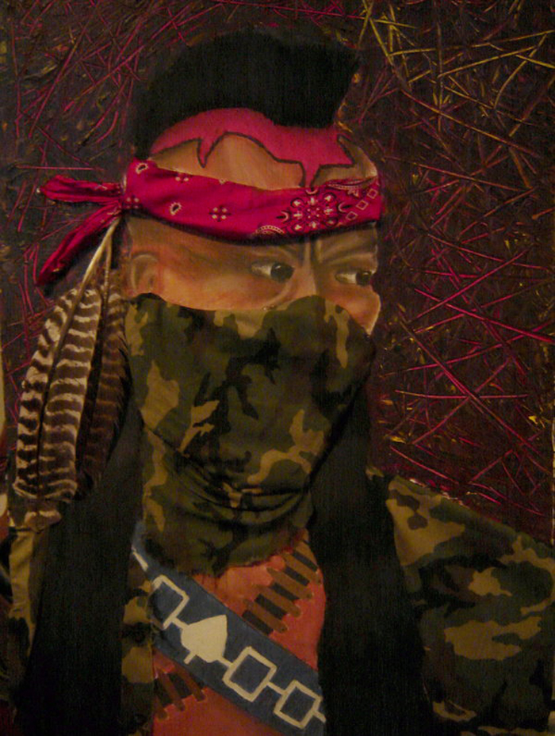 | 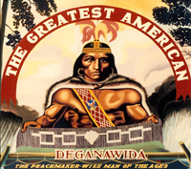
Painting and Drawing 1 (Oka Crisis Mohawk warrior) by Akokatssini (Steven J. Black Weasel), 2006  http://creativeresistance.org/painting-and-drawing-1-oka-crisis-mohawk-warrior/ | Peacemaker painting  by Karoniaktajeh Louis Hall  Posted on the website of the Kahnawake Longhouse (traditional government of Haudenosaunee Iroquois Confederacy)  http://www.kahnawakelonghouse.com/index.php?mid=1

Mohawks traditionally have had a strong warrior culture alongside their peacemaking history. Examine the two paintings by Mohawk artists (above).
- Identify and explain the significance of:
- symbols of Mohawk tradition shown in each painting
- symbols or words connected to present-day culture and events
- Discuss how peacemaking and war can be connected.
For further research: The Oka Crisis of 1990, on the Kanesatake Reserve in Québec (Mohawks vs. Québec military forces)

Audio link to listen to the show itself:

https://healthylifenet.mainstreamnetwork.com/media/IP012821.mp3

ANSWERS

- Map Questions
- Blue color means water (lakes)
- Red color means land that was controlled by the Haudenosaunee Confederacy before European arrival
- Green color means land that was never part of the Haudenosaunee Confederacy
- Yellow color means land that today belongs to Haudenosaunee nations, in the form of reservations (in the United States) or reserves (in Canada)
- White color is used for the names of the Five Nations of the Haudenosaunee (Iroquois) Confederacy
- Mohawk, Oneida, Onondaga, Cayuga, Seneca
- Mohawk
- New York State
- Kanawake is north of the black line indicating the border between the US and Canada (New York State and Quebec)
- (d)

- English language Vocabulary
- - C 2. – B 3. – D 4. – E 5. –A

- “Further Information” - multiple choice
- a) 2. b) 3. c) 4. b)

- Haudenosaunee seal

1. The largest image, in the center, is of the Great Tree of Peace.
2. This is important to the Haudenosaunee because it symbolizes their coming together, agreeing to govern themselves in their Confederation, and not war among themselves.
3. The animals, fish, birds, reptile represent the different clans.
4. The animals (deer, bear, wolf) are connected to the earth; the birds (heron, hawk, snipe) are connected to the air; the turtle, beaver and eel are connected to the water.
5. The human figures represent the leaders of the different clans, from each nation; they are connected together to show their unity.

- Statutes of Kateri Tekakwitha - suggested outline for essay

- Introduction - explain why Kateri is an important figure for Mohawks, and/or for Catholics regardless of their racial or ethnic background. Discuss how comparing different artists’ interpretations of Kateri can be useful for understanding her appeal.
- Statute at Cathedral of St. Francis of Assisi, Santa Fe, New Mexico
- Specific items
- First item
- Second item
- Third item
[Some examples: cross and rosary beads held in her hands - Catholicism; turquoise necklace and earrings - Indigenous southwestern Navajo and Hopi turquoise jewelry; dark skin and long dark hair - Indigenous – not European – looks; holding feathers – Indigenous traditions of respect for nature]
- Statue at St. Anne de Beaupré, Québec City
- Specific items
- First item
- Second item
- Third item
[Some examples: cold-weather boots and moccasins; long skirt– Mohawk clothing useful in cold weather; cross and rosary beads; headband, loosely braided hair; maple leaves around her feet – signifies Canadian national tree]
- Key similarities
- Both have Catholic items signifying her membership in that religious community
- Each has location-specific items that help people in that area to identify with her
- Key differences
- Made of different materials (bronze / marble) – locally available to sculptors
- Different choices of items to signify Indigenous roots
- Conclusion – personal preference

- Mohawk language – names and vocabulary
- -D 2. -E 3.- C 4. - B 5. – A

Attribution-NonCommercial-ShareAlike CC BY-NC-SA
Creative Commons License Others may remix, adapt, and build upon this work non-commercially, as long as they credit “Indigenous Perspectives – Randy Kritkausky” and license their new creations under the identical terms (ie non-commercial; share with attribution.)
Materials reviewed and updated, March 2023 - CS

