Abenaki Chief Don Stevens:
Tribal Recognition and Resilience in Vermont
Educational Materials for Broadcast # 2 –December 2020
“Indigenous Perspectives” program

1. Nulhegan Abenaki Tribe’s N’Dakinna Poster Ideas for discussions, essays, and artwork

- Give some examples of what “respect and protect” the land would mean in action; contrast these with examples of “disrespecting and damaging” the land.

- Why would the Abenaki feel especially strongly about the importance of respecting and protecting N’Dakinna?

- If you were making a poster to encourage other people to respect and protect a place that you value, what symbols and wording would you include?

- Design and draw your own poster, expressing your ideas about respecting and protecting.

- Drums are often used in Native American ceremonies, as well as in many different musical traditions. How can a drum make people feel connected to each other, and to the larger world of nature?

2 . Abenaki language – names and vocabulary

Match each name or phrase with its meaning.

- Abenaki A. first person, who formed himself from earth falling
from the hands of the Creator, according to Abenaki traditional beliefs

- N’dakinna B. human beings

- Nulhegan C. pine trees

- Coosuk D. Good-bye, take good care of yourself

- Adio wli nanawalmezi E. “our home”; refers to the land lived on by Abenaki
people for thousands of years

- alnombak F. “people of the dawn”; “people of the first light”

- Gluskabe G. “place of the wooden fish traps”

3. Information and ideas of the show Choose what you think is the best answer.

- The N’Dakinna Poster includes four different round emblems (seals), each for one of the four Abenaki tribes that are now officially recognized by the State of Vermont.
Below are the names of these four tribes, listed in order of their emblems shown on the poster, from left to right.

Which is the tribe that Chief Don Stevens belongs to?

- Koasek Abenaki of the Koas
- Nulhegan band of the Coosuk Abenaki Nation
- Elnu Abenaki tribe
- Missisquoi St.Francis-Sokoli band

- The presence of four different recognized Abenaki tribes in Vermont, rather than only one, indicates the Abenaki culture of:
- having one main ruler, with others paying tribute to that ruler
- having different languages, each spoken by a different Abenaki tribe
- each settlement having a fixed location
- living and making decisions in locally-based groups, without a central ruler

- Thinking in terms of “seven generations” of humans is a widespread Native American way to define responsibilities. According to Chief Stevens, the Abenaki think of their “seven generations” as:
- starting with yourself, then counting ahead six generations of your descendants into the future
- starting with yourself, then counting back six generations of your ancestors, into the past
- starting with yourself, counting back three generations (your great-grandparents, grandparents and parents); then counting ahead three generations (your children, grandchildren, great-grandchildren)
- all of the above

- Which best expresses Chief Stevens’ view of Abenaki ideas about their relationship to the land they lived on?
- Each tribe owned and controlled their own territory.
- People could do as they pleased on their own tribal lands, but couldn’t travel, hunt or fish on another tribe’s property.
- Out of respect for the land, they did not plant crops on it.
- People and tribes saw themselves as caretakers of the land, not as owners.

- The Abenaki Red Blanket Ceremony involves
- providing gifts to community members, “no strings attached”
- music and dancing in celebration of the summer solstice
- prayers and fasting before the annual meeting
- appreciation given to the skilled weavers in the community

- Together with his Abenaki heritage, Chief Stevens acknowledges traditions and religious beliefs that came from the influence of:
- French Catholic Jesuits
- Plains Indian tribes such as the Lakota and Apache
- English colonial rule before the American Revolution
- The early 20th century wave of immigrants from southern Europe

- Chief Stevens emphasizes the importance of feeling connected, not isolated, for the Abenaki people today. This includes connections to:
- the sources of food and life – plants, animals, and the earth
- the ancestors
- spiritual forces, such as the Creator, that can be carried by eagle feathers
- all of the above

4. Poetry by Joseph Bruchac

Joseph Bruchac, a Nulhegan Abenaki citizen, is a writer, storyteller and musician who lives in the northeastern section of New York State. These three poems, from At the End of Ridge Road (Canada: Milkweed Editions, Credo series, 2005), pp. 9-10, p. 15, p. 42 -are used here with his permission.

Before you read any of his poems, examine his photo – from the home page of his website – to look for clues to his interests and personality, from how he chose to be portrayed in this photo.

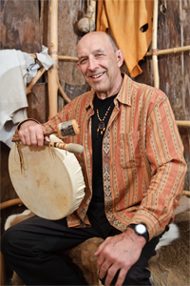
Photo by Eric Jenks
https://www.josephbruchac.com/

Read each of the poems out loud or silently, several times. The questions about each one are meant to encourage you to think about, and discuss, Bruchac’s messages and how he gets them across to the reader. There are guides to suggested answers on pages 11 - 12.

Time
Mink once stole the Sun
so the People could have light.

Then the Europeans came
and brought with them
a new thing called Time.

So Mink stole time.
He carried it off –
a big metal clock.

But instead of owning it
he soon found out
it owned him.

To this day Mink sits
with three big keys
around his neck.

Each day he uses them
to wind up Time
which owns us all now
the way we once owned the Sun.

Splinterville Hill

Near the mountains
footsteps on the ground sound hollow

as if to remind you
this Earth is a drum

we must watch our steps closely
to play the right tune

Beaches

Like the sand that was stone
before turning into dust
we have places to come from
before we go to others
Questions about Time

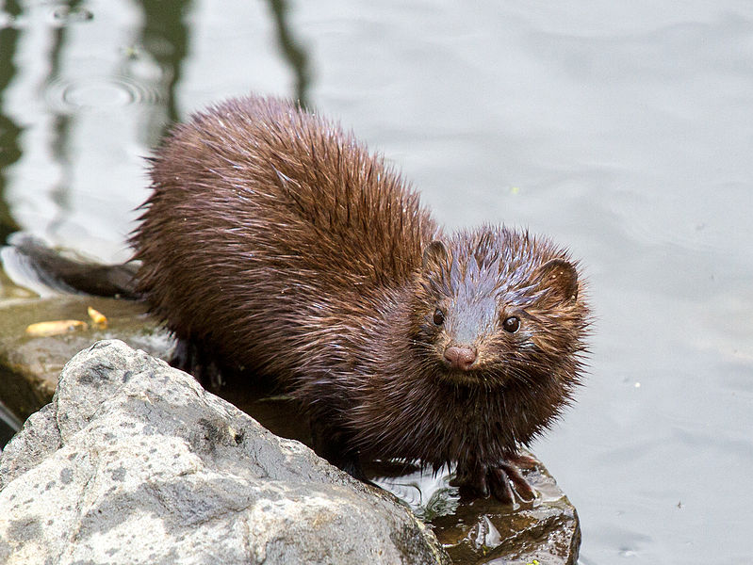
An American Mink in Capisic Pond, Portland, Maine, 20 May 2013
https://en.wikipedia.org/wiki/American_mink#/media/File:MinkforWiki.jpg
CC BY-SA 3.0 Credit: Chuck Homier

- Mink is an animal who features in traditional stories of indigenous people from many nations of Turtle Island. Mink can sometimes be heroic, but at other times is a dishonest “trickster”, trying to take advantages of others with his cleverness.

  - What two different things did Mink steal, in this poem?

  - Explain how Mink’s theft of Time backfired on him.

- How do the “three big keys” around Mink’s neck probably make him feel?

- Locate the pronoun shift in the last two lines of the poem. How does this help to connect the reader, on a personal level, to the results of Mink’s actions?

- Look back at the photo of Joseph Bruchac, on page 5. What do you notice in particular, after reading this poem?

- How does this poem encourage you to think about time in a new way?

Questions about Splinterville Hill

- A drum beat has tempo (speed – how fast or how slow) and also rhythm (patterns that the beats make). Does the tempo of this poem sound fast or slow to you – does it make you feel that it is speeding you up, or slowing you down?

- Find the two rhyming words within the second line, and then another word that has the same inner vowel sound. Think of a reason that the poet wanted to use this repeating sound here.

- If “the Earth is a drum”, what does that say about its connection with people?

Questions about Beaches

- What sound do the words “sand” “stone” and “dust” have in common?

- Can you connect that sound in any way with the title of the poem?

- How are the sand, the stone and the dust connected over time?

- What do you think the message of this poem is – what is Joseph Bruchac hoping to make us think about?

Questions about all three poems together

- A poet chooses each word, and format (capital or lower-case letters, line breaks, punctuation, etc.) very carefully, often with some hidden meanings.

What can you figure out from the fact that “Time” has a period (full stop) at the end, but “Splinterville Hill” and “Beaches” do not?

- Indigenous cultures frequently have strong themes of connection with nature, and people being open to receiving messages from the natural world. For each of the poems, figure out a “message from the natural world” that it carries.

- Choose one poem that you prefer over the others, and explain why you chose that poem. What about it stands out for you?

5. Map of the Wabanaki Confederation

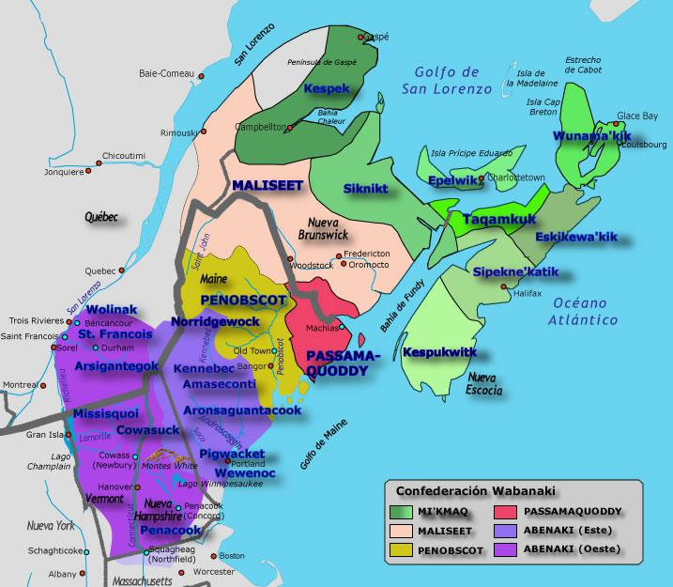
Credit: Pueblos Originarios de América https://pueblosoriginarios.com/norte/bosques/wabanaki/imagenes/wanabaki.jpg

- What does the light blue color on the map mean?

- What does the grey color on the map mean?

- What present-day boundary is show by the thickest (broadest) brown line?

- By contrast with the grey and light blue, what do the bright colors on the map mean?

- A confederation is a loosely-knit alliance, that respects differences among its different member groups. How many different member groups were there in the Wabanaki Confederation?

- For the Western Abenaki, name one tribe or band that was located in present-day Quebec, Canada, and another that was located in present-day Vermont or New Hampshire, United States.
- Present-Day Abenaki Organizations and Activities Individual or group projects
Increasingly in the 21st century, Abenaki communities have been organizing to maintain and expand their traditions as a people, to advocate for their view of land use and stewardship, and to achieve recognition of Abenaki identity and contributions.
Choose ONE of the following areas of recent Abenaki activity anywhere in N’Dakinna.
For the area you choose, find out what Abenaki people and leaders have been doing to revitalize (bring back to life; bring new life into) their place in their communities. You can also try to identify barriers and obstacles, and sources of disagreements, within the activity area you choose.

- hunting and fishing rights on public (state-owned) lands
- planting and harvesting ancestral seeds for the “three sisters” crops – corn, beans, squash
- basket-making as a traditional art form and present-day source of income
- government recognition of Abenaki tribal status
- exemption from laws on possession and use of eagle feathers and other ceremonial items
- travel across the current US – Canadian border
- Abenaki language
- music, dance, drumming, ceremonies – re-creation and re-vitalization
- state recognition of legal status; use of ID cards
- public health – access to resources, impact of Covid-19
- truth and reconciliation efforts to identify and deal with historical injustices (for example, in Vermont the public apologies for forced sterilizations of Abenaki women, during the “eugenics” movement of the 1930s – 1950s; in Quebec, the Healing Forest created in Stanstead Township)

ANSWER PAGE

2. Vocabulary answers
1 - F 2 - E 3 – G 4 - C 5 - D 6 - B 7 -A

3. Multiple choice answers
1 – B 2 - D 3 - C 4 – D 5 – A 6 - A 7 - D

4.Poetry answers

Time

1 a. Mink stole the Sun, and Time.
b.Time took over Mink’s life – Mink owns time, but it owns him too.

2. Mink probably feels chained up and trapped, imprisoned. He has to wind up the clock each day, so that gives him a work schedule set by the clock, instead of by his own wishes or by the natural rhythm of the day.

3.The poem starts in “third person singular” (“he”) – telling what Mink is doing. But in the last two lines it suddenly shifts to first person plural (“we” and “us”). This involves each reader personally, and invites each of us to think about ways that our lives would be different if we didn’t need to use clocks and organize our lives around clock time.

4. Joseph Bruchac is wearing a watch! So he is showing that he is a part of the “clock” culture, even though he’s aware that it can be a trap.

5.How much we let our lives be ruled by clock-time is a choice; if we are aware that it is a choice and not something that people always experienced, we can think about what it was like to live in a different way – by the rhythm of the seasons, for example, or by events happening in the physical and social world around us.

The Europeans brought Time in the clock sense to the People (Abenaki). The Europeans brought many changes – not necessarily good ones – that formed the lives of all of us today.

Splinterville Hill
1.The tempo of the poem is fairly slow; there are lots of long vowel sounds, and stressed syllables, that make it seem “heavy”. It feels more comfortable to read it slowly than to read it quickly.
2. “Ground” and “round” in the second line rhyme; “mountains” in the first line has the same “oun” sound. These help to slow the tempo, and also remind us that there is a melody, a tune, as well as a beat in the way we move through life.

3. People tend to move to the drum beat – fast or slow, depending on the beat. This applies to the pace of our lives. If the Earth is a drum, then how each of us moves on it, helps to set the pace for ourselves, and for others too.

Beaches

1.These three words all have “s” (“ess”), either at the start or the end.

2. Beaches can have waves of water rushing up onto them, making sounds sort of like “ess”.

3.Stone turns into sand, then dust, with abrasion and the passage of time. The order they are mentioned in (first sand, then stone, then dust) is 2nd (present day), then 1st (past), finally 3rd (future).

4.Each of us is here in the present day, but need to be aware of where we came from (our past), because our past has shaped us, and affects our choices as we go into the future.

All three poems together

1.Time tells a story and has an ending – we are all trapped into living by the clock. So, it has the period at the end. Splinterville Hill and Beaches are both about the rhythm of the life of the natural world. Those poems don’t come to a “full stop” at the end, because what they’re describing goes in circles, cycles, and changes, rather than ending.

2. Messages from the natural world can include our connections with it (the Earth/drum, the cycles of the seasons and time with the Sun as opposed to by the clock, the way that everything changes over time physically, and we change over time mentally, emotionally and spiritually as well as physically), etc.

3.The point of this question is to encourage the reader to think about reasons that they may prefer one of the poems – and also to encourage them to feel comfortable evaluating poems, as there are many dimensions to any poem, and different people will notice and respond to different things.

5 .Map answers

- water (Atlantic Ocean, and its gulfs and bays along the eastern coast)
- land that was never part of the territories of the members of the Wabanaki Confederation
- present-day boundary line between Canada and the United States
- different members of the Wabanaki Confederation (different tribes)
- six
- for Quebec, Canada: Wolinak, St. Francois, Arsigantegok
for US: Missisquoi, Cowasuck (Vermont); Penacook (New Hampshire)

Audio link to listen to the show itself: https://healthylifenet.mainstreamnetwork.com/media/IP122420.mp3

Materials reviewed and updated, March 2023 - CS
Attribution-NonCommercial-ShareAlike CC BY-NC-SA
Creative Commons License Others may remix, adapt, and build upon this work non-commercially, as long as they credit “Indigenous Perspectives – Randy Kritkausky and Carolyn Schmidt” and license their new creations under the identical terms (ie non-commercial; share with attribution.)

