Connor Chee, Navajo Pianist and Composer
Supplemental Materials for Broadcast # 17 – March 2022
“Indigenous Perspectives” program

I. Flag of the Navajo Nation

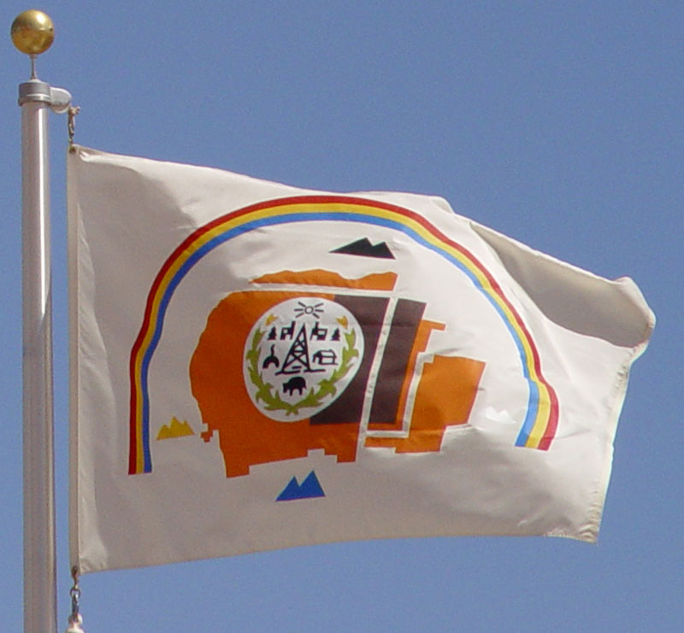
Image credit: Gerd Müller Creative Commons
https://upload.wikimedia.org/wikipedia/commons/b/b4/20030820-navajo-flag.jpg

The Navajo Nation’s flag has many symbolic elements; studying the flag can help you to identify some important parts of Navajo culture and history. For each image listed on the next page, find it on the flag, and then match it with its meaning.

The first match is completed already, to start you off.

Images on the flag

- Large orange shape
- White triangles to the right of the orange shape
- Blue triangles below the orange shape
- Yellow triangles to the left of the orange shape
- Black triangles above the orange shape
- Rainbow

Inside the white circle:

- Green curvy shapes_
- Yellow-orange little flowers above each green curvy shape
- Black multiple triangle shape
- Black animal figure

Meanings (answers are on page 16)

- Land of the Navajo Nation today (including much, but not all, of
Dinétah, the traditional Navajo homeland) ____A_____

- Sign of protection and harmony for all of the traditional Navajo _________
homeland

- Sacred mountain in the northern part of Dinétah (Mount Hesperus) ________
- a sheep; source of food and wool ________
- corn stalks; source of food and symbol of renewal of life each spring ________
- Sacred mountains in the western part of Dinétah (San Francisco Peaks)_______
- Sacred mountain in the southern part of Dinétah (Turquoise Mountain)________
- Oil derrick; indicates mineral resources and source of tribal income _________
- Corn pollen; considered sacred and used in healing ceremonies _________
- Sacred mountain in the eastern part of Dinétah (Mount Blanca) ________

II. Vocabulary – match each word from the discussion with its best definition (answers are on page 16)

words about people being excluded (kept out) of a larger group:
disenfranchisement _____ tokenism _____ micro-aggressions _______
- casual words and actions by people in a dominant group, that enforce a sense of inferiority in others
- losing the right to vote; losing a say in things happening around you
- when someone from a minority group is chosen for an honor, mainly to make a prejudiced dominant group look like they are being fair
words about people gaining strength and confidence despite hardships:
balance _______ emergence ________ resilience _________ revitalization __________
- bringing new life and energy to something that has been declining
- bouncing back stronger in response to set-backs
- growth and change from one form to another; becoming visible to others
- achieving harmony between different, often conflicting, elements
references to particular events, places or people:
Dinétah ___ Indianist movement _____ Standing Rock _____ Water Protectors ____
- American classical musicians (1880s – 1920s) who used elements of Native American traditional music in their own compositions as part of a new trend
- Indigenous people who organize to defend their land and keep it healthy and free from pollution; often led by women building on traditions that connect women to water as a source of life
- The Lakota Sioux reservation which became a rallying point for people from many tribes, joined by non-Natives, in support of the Sioux in their protests against the Dakota Access Pipeline. That pipeline would run underground, through Sioux land protected by treaty, to transport natural gas from North Dakota to Texas. The protests started in 2016 and are ongoing.
- Navajo language term for the traditional homelands of the Navajo (“Diné” means “the people” in Navajo)

III. Comparing Two Maps (answers are on page 16)
Navajo Nation  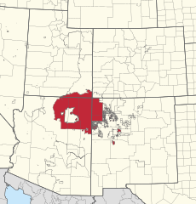 | Diné Bikéyah  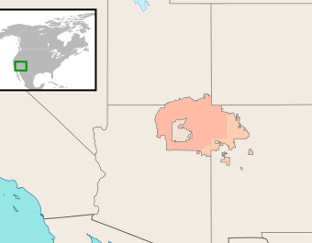

- Compare these two maps of the Navajo Nation lands; list all the differences you can find between the two maps. Try to find at least three.

- Figure out the best answer for each of the following multiple choice questions, based on these maps.

- Both maps show a non-Navajo Nation space totally enclosed by the Navajo territory. This is:
- land controlled by the U.S. Forest Service
- part of the legal territory of Arizona
- territory where no human has ever been able to travel
- the Hopi reservation

- Traditional Navajo territory was in areas now part of four states: Arizona, New Mexico, Utah and Colorado. Which state has the largest amount of Navajo Nation land now?
- Arizona b) Colorado c) New Mexico d) Utah

- There is no Navajo Nation land in:
- Arizona b) Colorado c) New Mexico d) Utah

- The land in the southwestern corner of Colorado, that borders directly on the Navajo land, belongs to which other Native American nation? (hint: what is the name of the US state to the west of Colorado?)
- Apache b) Hopi c) Ute d) Zuni
IV. Corn Grinding Song and Navajo Vocable for Piano No. 9
Connor Chee says: “Corn Grinding Song No. 3 is the chant that inspired Navajo Vocable for Piano No. 9. Playing that track might be an interesting way to let listeners hear how the chant is transferred to the piano.”

Listen to the Corn Grinding Song (1 minute 21 seconds), and then Navajo Vocable for Piano (2 minutes 43 seconds) (double-click on the image while connected to the internet; then open a music-playing program on your computer.)
- Identify and sing or hum the lead melody that you hear in both pieces.
- Identify and tap out the beat you hear in both pieces.
- Pick out other similarities between the two pieces
- Identify differences between the two pieces
- The Corn Grinding Song was created by working people, to accompany the rhythm of their work. What are some impacts when people sing together while working on a shared task? What other examples do you know of this kind of song?
V. Scenes from Dinétah - Individual or Group Project (needs internet access)
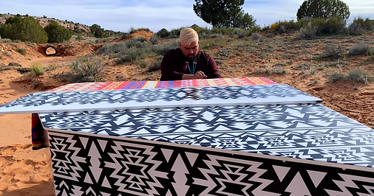
Image credit: www.connorchee.com used by permission

Each of the short videos (3-4 minutes long) in this series shows Connor playing one of his original piano compositions, that accompany scenes from present-day Navajo culture in Dinétah.

Available through direct link from Connor Chee’s website: www.connorchee.com
Weaving Horses Sheep

Available through YouTube:
Cedar https://www.youtube.com/watch?v=jPjor8NXnmc
also: Fry Bread Pathways Horny Toad The Gila Monster

Activity: Watch and listen to one of these videos; organize and discuss your findings and thoughts. Your ideas can be spoken (in a presentation or group discussion), written (essay or report), or both.
- Identify specific elements of each of the following in the video you watch:
- the natural world - animals, landscape (mountains, rocks, sky, sun), trees, plants, etc.
- humans and human-made objects shown in the video (include Connor);
- how the music fits with the action in the video – tempo, rhythm, melodies, etc.
- Discuss the extent to which you get a sense of the distinctive Navajo landscape and culture from the video.
- How would you go about applying the “Scenes from…….” approach in your own life, to characterize your own community in visual form, along with appropriate music? You might create a list of places, scenes or topics you would want to include, and people you would want to involve.

VI. Reading Comprehension - selections from NavajoLand: A Native Son Shares His Legacy by LeRoy DeJolie, used here with permission from Arizona Highways.
Read each of the following selections, written by Navajo photographer LeRoy DeJolie, and answer the questions below. This is meant to encourage you to read carefully, not only for details about Navajo culture, but also for the “big picture” –the main, most important ideas that the author wants to communicate to you.
WE ARE THE DINÉ – THE PEOPLE
We call ourselves the Diné. The name “Navajo” was given to us by other Indian tribes and by the white people. We have always been a people who adapt to survive. From our migrating ancestors’ days, time and again we have come across new ways of living and have made them our own. Farming, stock raising, silversmithing, and weaving, all of these skills we learned because we found them useful.

Navajo mythology tells us that Spider Man taught our ancestors how to make a loom and Spider Woman taught them how to weave. To this day, traditional Navajo weavers recognize that legacy with a “spirit line” woven into patterns. Documents written in the early 1700s by Spanish explorers in what’s now the American Southwest mention the Navajos’ weaving skills. By then, Navajo textiles were an important trade item.

The art of silversmithing was introduced to us by the Spaniards around the middle of the 19th century. Now, anyone interested in Indian silver thinks first of the Navajos. The Diné are highly skilled in their ability to create exquisite and multifaceted art in the form of jewelry. Gemstones, particularly turquoise, are inlaid to enhance the ornamental look. Navajo lore teaches that turquoise was brought to the present world by Holy People, so turquoise is especially valued because of its ceremonial significance.

We have always clung to the familiar – our livestock and ancestral land and stories of our history and culture. Many Navajos today continue
the practice of sharing stories and singing the songs of our forefathers. Details of stories told in one clan may differ from details of the same story told in another clan. But essentially the stories explain who we have been and who we are. This is how we keep our ways and traditions alive for our children to follow. The high point of any culture is reached when the younger generation places high value on learning it. It thrills me when Navajos and non-Navajos come to know the sacred associations of Diné and Dinétah. However, I’m concerned that our culture is vanishing from the lives and memories of many of our people as they are swept into more dominant cultures around us and adapt new behavior – much as our ancestors did – to survive.

[Some of] our stories are told by the elders only in the wintertime when the snakes are asleep. Navajos, like other Indians, feel that serpents are the guardians of sacred lore and will punish those who treat it lightly. Our stories are full of poetry and accounts of epic events. One of the events is referred to as the Long Walk.

The tragic story begins in 1863 when the U.S. Army under Col. Kit Carson uprooted 9,000 or more members of my tribe from their homes and hiding places. The soldiers laid waste to dwellings, stock animals, and stored foods, and they held the people captive. In the following year, the soldiers drove the Navajos – in a march line that extended for 8 miles –to Bosque Redondo in eastern New Mexico, where they were forced to build the Army’s Fort Sumner and live under wretched conditions for years.

During the period of exile, so strong was the call of the homeland that several hundred Navajos escaped and fled to the western regions among the slot canyons on the Colorado Plateau. There they joined those who had not been captured. Once a treaty was signed in 1868, the Army feed the remaining exiles, many of whom returned to Dinétah. By then, the Navajos had lost perhaps 25% of their people.

True or False? Based on the reading “We Are the Diné”,
- decide whether each statement below is “True” or “False”, and
- for every statement that is false, change the underlined section to make that statement true. (answers are on page 17)

- The Navajo have rarely been willing to adapt new skills and technologies in order to survive.

- In Navajo culture, spiders and snakes are respected as teachers and messengers from the spirit world.

- The photo below shows Navajo skilled craftsmanship using glass and brass.
Photo credit

- The event the Navajo call the Long Walk (1863-1868) resulted in the Navajo permanently leaving Dinétah.

- Their experience at Bosque Redondo is something that the Navajo remember today with sorrow.

- Many of the Navajo traditional stories discuss experiences of their ancestors with gods and other beings from the spirit world.

- LeJolie says that the Navajo pattern of adapting their way of life to new opportunities could lead to benefits if present-day Navajo give up their language, customs and stories to join the mainstream United States culture.

Mount Blanca (Sacred Mountain of the East)

The Holy People, or spirits, taught the Diné to address their four sacred mountains and corresponding directions beginning in the East and progressing clockwise to the South, West and North. These mountains define the boundaries of Dinétah, the land given to the Diné by Changing Woman.

In creating the current, Glittering World, the Holy People fastened Mount Blanca, white mountain, to Earth by a lightning bolt, decorating it with white shells, white lightning, white corn, and dark clouds and covering it with a sheet of daylight. Then they brought small, stone images of Rock Crystal Boy and Rock Crystal Girl from the underworld and set them on the mountain, where they came alive.

Mount Blanca, as all the sacred mountains do, provides a prominent landmark by which traveling Navajos can determine their location and home. As one Diné legend holds, when a father taught his two young boys about worldly matters, both sweet (tobacco) and dark (war), he took them on many travels throughout Dinétah. At different points he would ask them, “Where do you belong in the world? Show me your home.”

As they walked along flat lands, the boys became confused. They could not say where they belonged, nor whether they were home. Only when they saw the mountains – each with a distinct personality represented by the colors white, turquoise, yellow and black – could the boys find their way and feel the rhythms of their homeland and their people.

The Diné believe there is a male and a female to all things. In the Navajo view, rain, one of Earth’s four main elements (the others are light, air, and pollen) is designated as male when it falls in stormy sheets accompanied by lightning. In contrast, gentle, female rain soothes. Male downpours help to distinguish Mount Blanca from the other sacred mountains.

Mount Blanca lies in the Sangre de Cristo range in southern Colorado’s San Luis Valley near Alamosa. Within the range there are large populations of elk and Rocky Mountain bighorn sheep. The mountains in the range reach higher than 14,000 feet – Mount Blanca stands at 14,345 feet – with skiing and rock-climbing locations found throughout the range.

True or False? After reading “Mount Blanca – Sacred Mountain of the East”:
- decide whether each statement below is “True” or “False”, and
- for every statement that is false, change the underlined section to make that statement true. (answers are on page 17)

- The Navajo creation stories tell how the gods made the mountains and other features of the landscape of Dinétah.

- Rock Crystal Boy and Rock Crystal Girl, in Navajo legends, were born on Mount Blanca.

- Each sacred mountain has its special color; starting in the East, then going South, West, and finally North, those colors are: white, turquoise (blue/green), red and black.

- Each sacred mountain has its own personality and character; Mount Blanca is known for its constant sunshine.

- When the boys in the legend were walking with their father on the flat land, they were happy when they could not see the mountains.

- The four main elements of the world, according to Navajo traditions, are rain, pollen, sunlight, and earth.

- The Navajo view of the world includes the idea that all things have both male and female aspects, different but equally valuable.

VII. Map of Navajo Reservation land changes, 1868-1934
Use the readings by LaJolie, and the current flag of the Navajo Nation, to answer the questions based on the map below. (answers are on page 17)
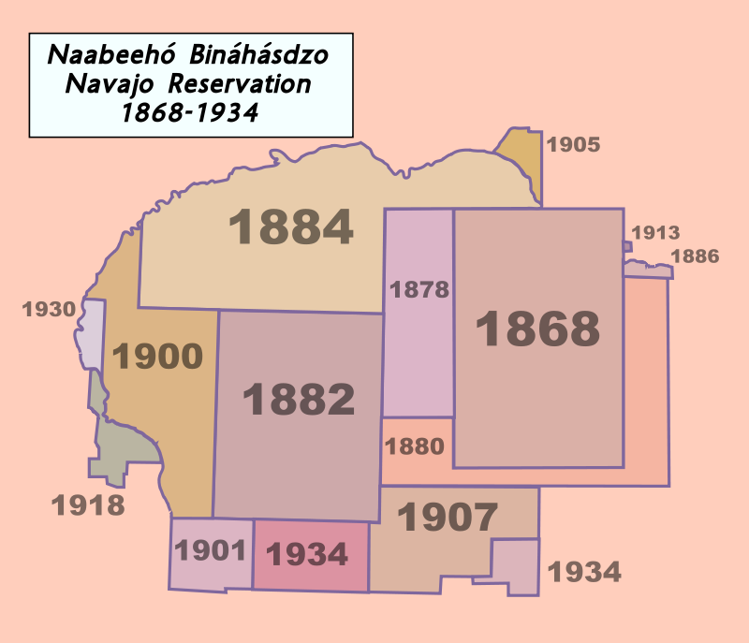
Image credit: Seb az86556 Creative Commons license

- The earliest land officially granted to the Navajo people by a treaty with the US government, became the Navajo Reservation in:
- 1823 b) 1868 c) 1918 1934

- On today’s Navajo flag, this original parcel is shown as a:
- white circle b) blue triangle c) rainbow d) dark brown rectangle

- Which historical event is most associated with the 1868 treaty land grant?
- Navajo victory in their long-running conflict with the Hopi
- A major volcanic eruption in the Turquoise Mountain area
- the San Francisco Gold Rush
- Return of the Navajo people who survived the Long Walk and imprisonment at Bosque Redondo

- Which is the most accurate general statement about the trend from 1868-1934, as shown on this map?
- the Navajo gradually gained land
- the Navajo gradually lost land
- the land the Navajo controlled was basically unchanged
- the Navajo increasingly had to share their land with other tribes

- If this map had included the four sacred mountains, where would those mountains have been located on the map?
- all inside the 1868 land parcel
- all inside the 1882 parcel
- one each, inside the 1880 (east), 1934 (south), 1930 (west) and 1884 (north) parcels
- outside any of the Navajo Reservation land

- What do you think is the reason that this map stops at 1934?
- The Navajo lost control of their entire reservation in 1935
- The Ute, Zuni, Hopi and Pueblo nations all challenged Navajo land rights
- An act of the US Congress in 1934 combined the existing parcels under the control of one Navajo tribal government
- The Navajo lost all their land in Colorado in 1934

VIII. Individual or Group Projects: Navajo Photographers
Connor Chee’s distinctive musical style comes from his own unique approach to combining Navajo musical traditions and European-based classical music. In a similar way, current Navajo photographers are using their skills to portray the beauties of the landscape of Dinétah and of the Diné (Navajo people).
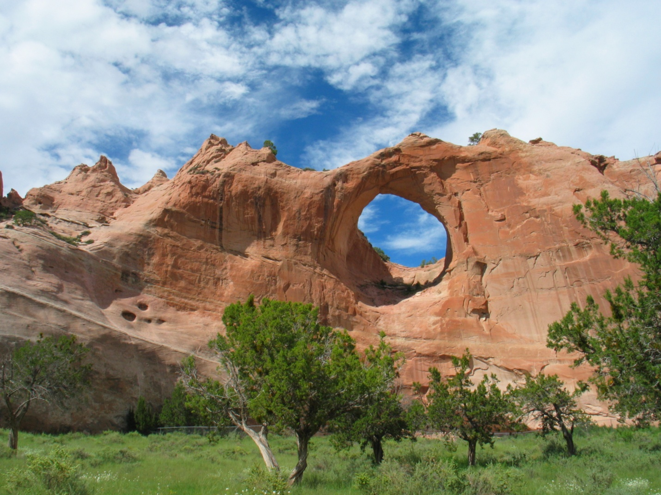
Tségháhoodzání, the "Window Rock”

Find some examples of the work of Navajo photographers, and prepare either a spoken presentation or a written essay in which you explain

- the types of scenes the photographer specializes in,
- why the photographer chooses those scenes (find and comment on one or two direct quotations from the photographer about their work), and
- your reactions to what you have learned about the Navajo way of life, from these photographs.

Print Resource: The book NavajoLand: A Native Son Shares His Legacy (80 pages) is an outstanding source of photographs and explanations by LeRoy DeJolie. Phoenix, Arizona: Book Division of Arizona Highways magazine, 2005.
It is still in print; you can buy it from Arizona Highways: https://www.shoparizonahighways.com/navajoland

Internet Resources: See the websites of the following Navajo photographers.

Mylo Fowler https://www.mylofowler.com/Mylo-Fowler
Valonia Hardy https://www.vhardyphotography.com/
LeRoy LaJolie https://www.deseret.com/2005/8/28/19908939/beauty-of-navajoland-captured
Priscilla Tacheny https://ptacheney.artspan.com/home
Eugene Tapahe https://www.tapahe.com
Donovan Shorty https://www.powwows.com/shorty-studios-navajo-photography/

Answers
I. Flag questions
1-A 2-F 3-E 4-J 5-G 6-D 7-C
8-I 9-H 10-B
II. Vocabulary
disenfranchisement B
tokenism C
micro-aggressions A
balance G
emergence F
resilience E
revitalization D
Dinétah K
Indianist movement H
Standing Rock J
Water Protectors I

III. Comparing two maps
- Differences between the maps: (you might also find others)
- Titles – map 1 is in English language, map 2 in Navajo language
- Colors used for Navajo land: map 1 has Navajo land in red; map 2 has Navajo land in orange/light orange
- Insert map of North America: only map 2 has this
- Zoom – map 1 shows more surrounding land area than does map 2
- County lines within state borders – only map 1 has these
- Color of non-Navajo land area in US – map 1 uses white, map 2 pale pink
- Land in Mexico – map 1 uses grey (instead of white) to show Mexican land; map 2 makes no distinction, just uses the same pale pink as for US
- Eastern-most section of Navajo land – map 2 shows this in a separate color (called the “checkerboard area”, it’s a mix of privately owned Navajo and non-Navajo lands; complicated history)

- Multiple choice 1- d 2 – a 3- b 4- c

VI. Reading comprehension
“We Are the Diné”
- False – often
- True
- False – turquoise and silver
- False – temporarily living / eventually returning
- True
- True
- False – problems /losses (or any other negative type of word)
“Mount Blanca”
- True
- False – came alive on the mountain / were put on the mountain by the gods / were carried to the mountain from the underworld
- False – yellow
- False – violent storms/ heavy rains
- False – confused / sad / upset
- False – air
- True
VII. Map of Navajo Reservation land changes
- - b 2. - d 3. - d 4. - a 5. - d 6. - c

Attribution-NonCommercial-ShareAlike CC BY-NC-SA
Creative Commons License Others may remix, adapt, and build upon this work non-commercially, as long as they credit “Indigenous Perspectives – Randy Kritkausky & Carolyn Schmidt” and license their new creations under the identical terms (ie non-commercial; share with attribution.)

Creative Commons CC0 1.0 Universal Public Domain Dedication. https://en.wikipedia.org/wiki/Navajo_Nation#/media/File:2430R_Navajo_Nation_Reservation_Locator_Map.svg
Diné bizaad: Diné Bikéyah beʼelyaaígíí By Seb az86556 English: Navajo Nation map, with the "checkerboard" area in a lighter shade This file is licensed under the Creative Commons Attribution-Share Alike 3.0 Unported license. https://commons.wikimedia.org/wiki/File:DineBikeyahBe%27elyaigii.svg
NavajoLand: A Native Son Shares His Legacy. Text and photographs by LeRoy DeJolie. Phoenix, Arizona: Book Division of Arizona Highways magazine, 2005. pp. 18-20
https://upload.wikimedia.org/wikipedia/commons/thumb/4/45/Old_and_new_Navajo_bracelets.jpg/159px-Old_and_new_Navajo_bracelets.jpg photo credit: Silverborders, Creative Commons Attribution 3.0 Unported license
NavajoLand, pp. 26-27.
https://commons.wikimedia.org/wiki/File:Nn_border_hist_map.svg CC BY-SA 3.0
by Ben FrantzDale - Own work, Creative Commons license CC BY-SA 3.0, https://commons.wikimedia.org/w/index.php?curid=1097946

