Thanksgiving from an Indigenous Perspective
Educational Materials for Broadcast # 1 – November 2020
“Indigenous Perspectives” program
Audio link to listen to the show itself: https://healthylifenet.mainstreamnetwork.com/media/IP112620.mp3
1.Names of Indigenous People discussed on this show, and their traditional territories

Abenaki “People of the dawn land” – mainly living in what is now Vermont in US and Quebec in Canada- part of the Wabanaki Confederation

Aninishinaabe “Original people” - general term for Algonquin-
language tribes such as the Ojibwe, Odawa and Potawatomi, from the Great Lakes region, now in US and Canada

Haudenosaunee “People of the longhouse” - confederation of six
Indigenous nations (Mohawk, Onondaga, Oneida,
Cayuga, Seneca, Tuscarora), mainly in what is now New York State (in US) and Quebec and Ontario (in Canada)

Wampanoag Indigenous people in what is now eastern Massachusetts
in the United States, who encountered the immigrants from England (“Pilgrims”) in1620

2. Vocabulary

Match the word with its meaning.

- Bozho A. Today (in Potawatomi language)

- N’dakinna B. North America (reference from creation story)

- Migwetch C. Thanks; I give thanks (in Potawatomi language)

- Ngom D. Hello; greetings (in Potawatomi language)

- Turtle Island E. Abenaki name for their traditional territory

3.Maps of Indigenous peoples’ original locations
For each group, choose the map that shows their original territory (before European colonial settlements).

Map A : Abenaki, Aninishinaabe, Hodenosaunee, or Wampanoag territory ?

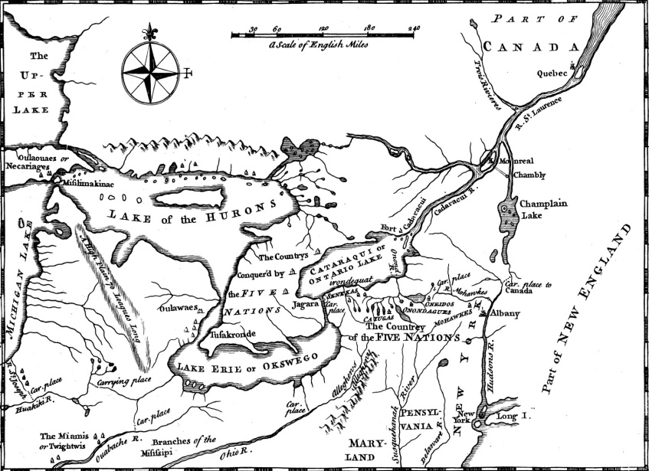
https://www.britannica.com/topic/Iroquois-Confederacy

Map B : Abenaki, Aninishinaabe, Hodenosaunee, or Wampanoag territory?

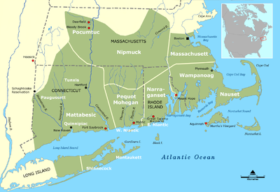
https://en.wikipedia.org/wiki/Niantic_people#/media/File:Tribal_Territories_Southern_New_England.png
Map C : Abenaki, Aninishinaabe, Hodenosaunee, or Wampanoag territory?
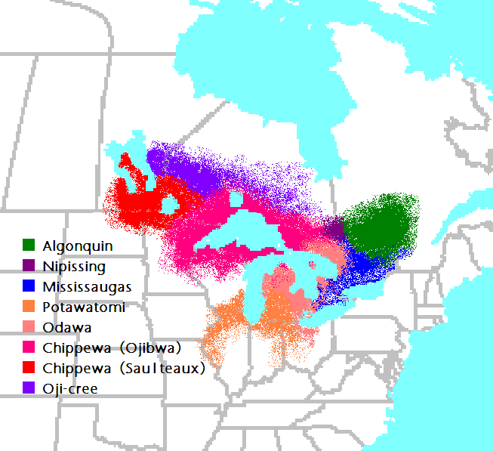
https://commons.wikimedia.org/wiki/File:Anishinaabe-Anishinini_Map.PNG

Map D: Abenaki, Aninishinaabe, Hodenosaunee, or Wampanoag territory?
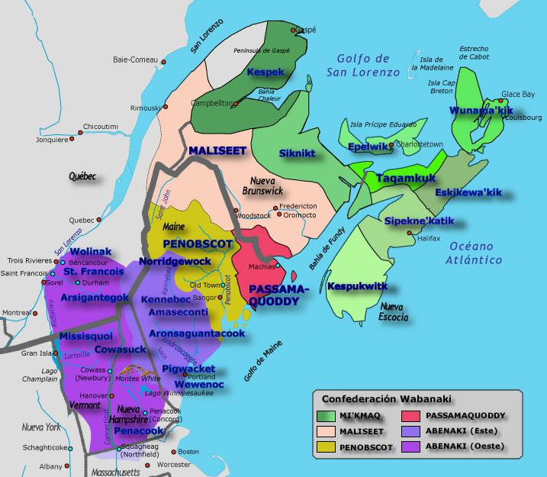
https://pueblosoriginarios.com/norte/bosques/wabanaki/imagenes/wanabaki.jpg

4. Key ideas of the show
Choose what you think is the best answer.

- The show starts with a reference to “N’dakinna, the unceded traditional territory of the Abenaki people.”

In this context, “unceded” means:
a) unused; never lived on by humans
b) never mapped
c) never planted with food crops
d) never legally surrendered or given up

- The Potawatomi “Morning Song” and the Haudenosaunee “Greetings and Thanks” statement are both examples of Native American cultural expressions of:
- gratitude to the natural world
- determination to conquer obstacles
- harmony with other people, regardless of their race
- the importance of planning ahead

- The English Pilgrims’ view of their destination in the “New World” as the “desolate wilderness” expresses their
- feelings of kinship with the trees, birds and animals of the New World
- distrust of the natural world, and fear of the unknown
- feeling that their God would not help them in the new place
- expectation of finding cities similar to those they had lived in, in Holland

- Randy Kritkausky discusses his own experiences with the fireflies, owls and coy-wolves as:
- comforting, because they all became good pets
- scary, because he couldn’t understand what they were doing
- mournful, because they never came back
- inspiring, because he felt they were trying to tell him something

5. Expressions of thanks, and the obligation to reciprocate (gave back in return) when you receive a gift or favor, are both examples of:
a) ideas that can never become the basis for long-term cooperation
b) values that are exclusive to Native American culture and people
c) awareness of interdependence and connection
d) expressions of dominance over the natural world

5. Images of Turtle Island - inspiration for discussions, essays, and/or artwork
Compare and contrast the three different artistic expressions of Turtle Island.
What do all three share? What is unique about each one? Which one has the most appeal for you, and can you explain why? Create your own image of Turtle Island by drawing, painting, sculpting, or any other art form, using the medium of your choice.
Credit: https://www.communitynewscommons.org/wp-content/uploads/2016/06/turtleisland-markwagner.jpg  Credit: https://www.inspiringyoungminds.ca/turtle-island-poster.html | 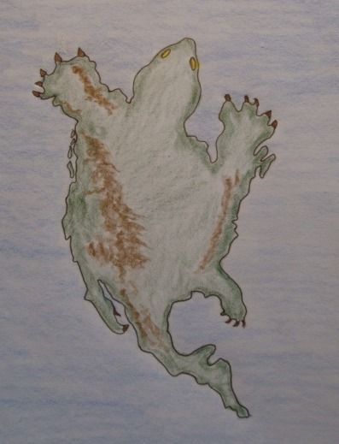  Credit: https://i.iheart.com/v3/re/new_assets/602888741feec7809d947b0a
6.Research and Create Your Own Land Acknowledgment - individual or group project
- Identify which Indigenous peoples originally inhabited the area where you now live.
- Online resource – https://native-land.ca – Native Land Digital provides this interactive map that is open source and free to use.
- Local or regional historical societies often have some of this information
- If you can locate any present-day tribal members in your area, they may also be interested in sharing their knowledge.

Don’t be surprised if you get somewhat contradictory information. As with nations today, Indigenous peoples consisted of nations who often struggled over boundaries, which shifted over time. You can acknowledge more than one Indigenous people or nation, even though protocol is to make every attempt to respect those who have a current or most recent historical claim to the territory.

- Once you have identified the Indigenous people who originally populated your area, learn something about them, to include in your acknowledgment. Emphasize that the connection between the Indigenous people and the land is an enduring one, despite any historic dislocations and migrations or removals of the past several centuries.

A territorial acknowledgement is not an end point; it is a beginning. Ask yourself who the audience is for your acknowledgement and what your goal is. Create a brief message appropriate to the audience.
SOME EXAMPLES OF LAND ACKNOWLEDGMENTS
"The University of Alberta acknowledges that we are located on Treaty 6 territory, and respects the histories, languages, and cultures of First Nations, Métis, Inuit, and all First Peoples of Canada, whose presence continues to enrich our vibrant community." - University of Alberta, Edmonton, Canada
“We pause to acknowledge that we are gathered on land which has served as a site of meeting and exchange among indigenous peoples since time immemorial. The Western Abenaki are the traditional caretakers of these Vermont lands and waters, which they call N’dakinna or homeland. We remember their connection to this region and the hardships they continue to endure. Let us take a moment of silence to pay respect to the Abenaki Elders and to the indigenous inhabitants of Turtle Island past and present. We give thanks for the opportunity to share in the bounty of this place and to protect it. We are all one in the sacred web of life that connects people, animals, plants, air, water, and earth.” - Middlebury College, Vermont, US

- When using your territorial acknowledgement before any group event, be very careful to read it aloud slowly and respectfully. Be sure to practice pronunciation of any unfamiliar names, well in advance.

- Think creatively about next steps that you can take toward understanding and acts of reconciliation and restitution, to show that you respect the history and continued presence of the Indigenous people in your area.

For more information on Land Acknowledgments, see Laurier Students Public Interest Research Group website: http://www.lspirg.org/knowtheland

ANSWER PAGE
2. Vocabulary answers
1-D 2-E 3- C 4- A 5-B

3.Map answers and source credits

Map A – Haudenosaunee
Map B – Wampanoag
Map C – Aninishinaabe
Map D - Abenaki

Map A: Haudenosaunee
Credit: Map of the initial nations of the Iroquois Confederacy, from History of the Five Indian Nations Depending on the Province of New-York, by Cadwallader Colden, 1755. Library of Congress, Rare Book Division, Washington, D.C.
Link: https://www.britannica.com/topic/Iroquois-Confederacy

Map B: Wampanoag
Credit: Wikipedia
Link: https://en.wikipedia.org/wiki/Niantic_people#/media/File:Tribal_Territories_Southern_New_England.png

Map C: Aninishinaabe
Credit: Wikimedia Commons
Link: https://commons.wikimedia.org/wiki/File:Anishinaabe-Anishinini_Map.PNG

Map D: Abenaki
Credit: Pueblos Originarios de America
Link: https://pueblosoriginarios.com/norte/bosques/wabanaki/imagenes/wanabaki.jpg

4.Multiple choice answers

1-D 2-A 3-B 4-D 5-C

++++++++++++++++++++++++++++++++++++++++++++++++++++++++++++++++++
Attribution-NonCommercial-ShareAlike CC BY-NC-SA
Creative Commons License Others may remix, adapt, and build upon this work non-commercially, as long as they credit “Indigenous Perspectives – Randy Kritkausky and Carolyn Schmidt” and license their new creations under the identical terms (ie non-commercial; share with attribution.)
Materials reviewed and updated, March 2023 - CS

